**Step 1: Add Room list in Office 365 --> Resources -->Rooms & equipment**

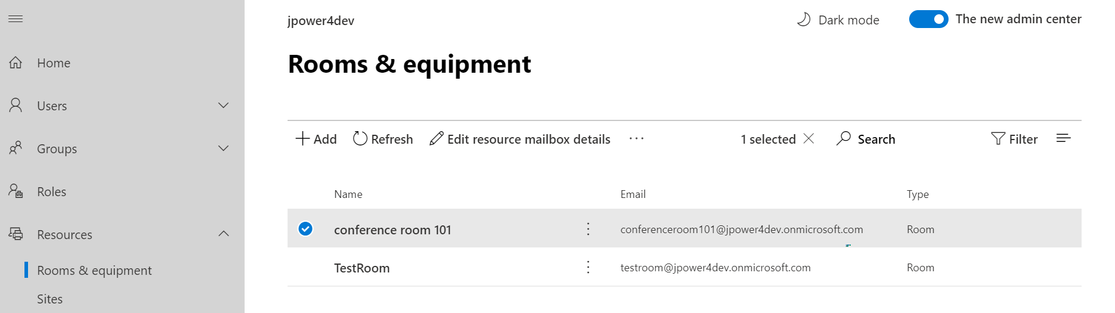

**Step 2: Connect Exchange PowerShell**

1. Open Windows PowerShell
2. Set-ExecutionPolicy Unrestricted
3. Y
4. $UserCredential = Get-Credential
5. $Session = New-PSSession -ConfigurationName Microsoft.Exchange -ConnectionUri https://outlook.office365.com/powershell-liveid/ -Credential $UserCredential -Authentication Basic -AllowRedirection
6. Import-PSSession $Session

**Step 3: We need to create one Distribution Group using PowerShell (As we cannot create DG with RoomList type using GUI mode.)**

1. New-DistributionGroup -Name "MS Teams meeting room" -Roomlist

**Note**: You can keep any name that you would like to have for the Distribution Group, but Distribution Group should contain Roomlist, otherwise we will not get an option to add this DG while creating a meeting.)

**Step 4: Add the Room/Resource mailbox in it by the following command.**

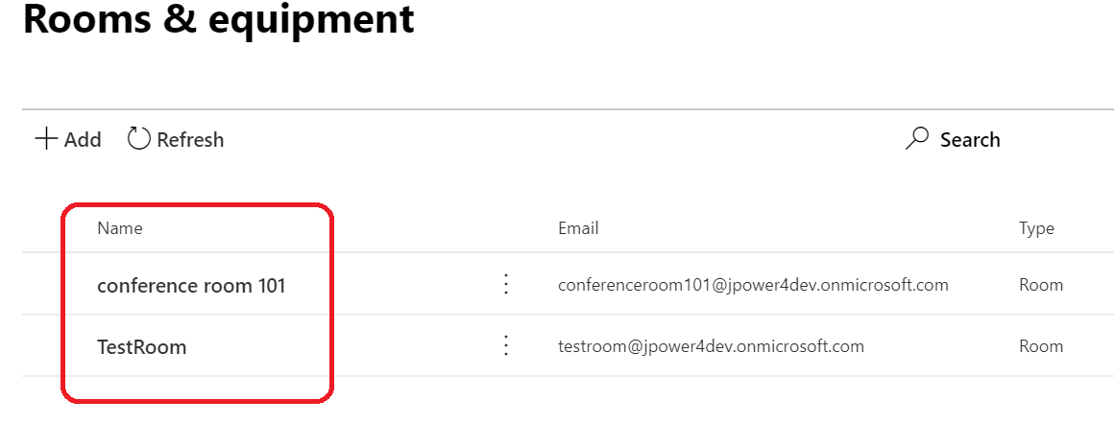

1. Add-DistributionGroupMember -Identity “MS Teams meeting room” -Member “TestRoom”
2. Add-DistributionGroupMember -Identity “MS Teams meeting room” -Member “conference room 101”

**Note:** Only room mailbox or room list can be added into room list

**Step 4: Add new room**

1. If you want added new room,
2. Add it inOffice 365 --> Resources -->Rooms & equipment

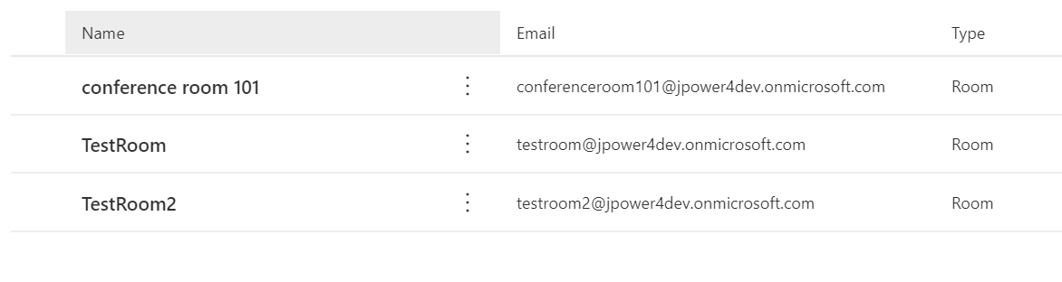

1. Then Open Windows PowerShell and connect Exchange PowerShell follow **Step 1**)
2. Add-DistributionGroupMember -Identity "MS Teams meeting room" -Member "TestRoom2"

**Step 5: Test in Microsoft Teams – Create new meeting in Teams and test it**

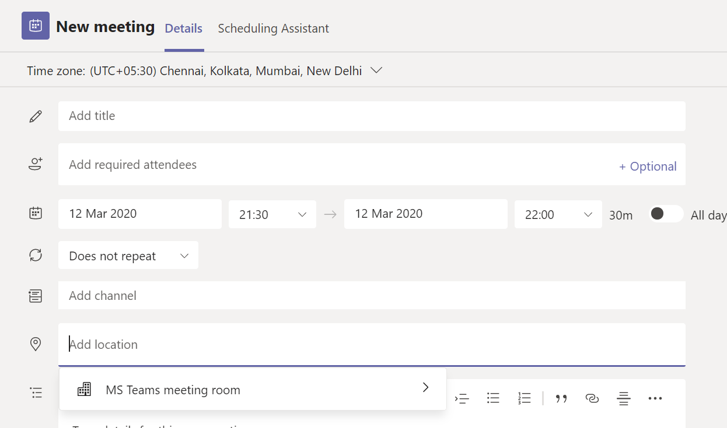

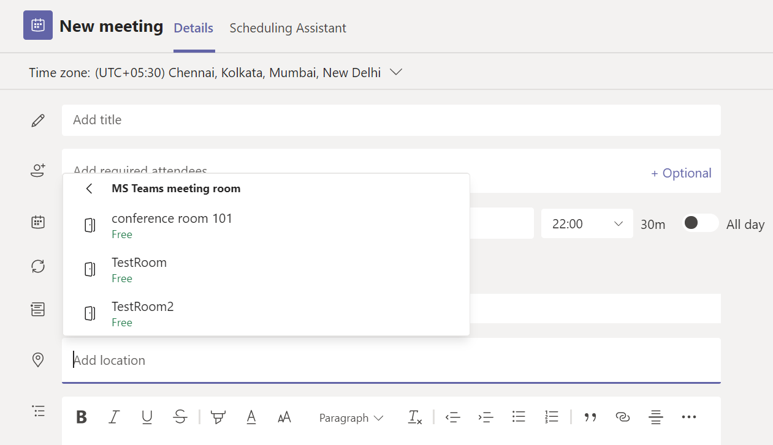

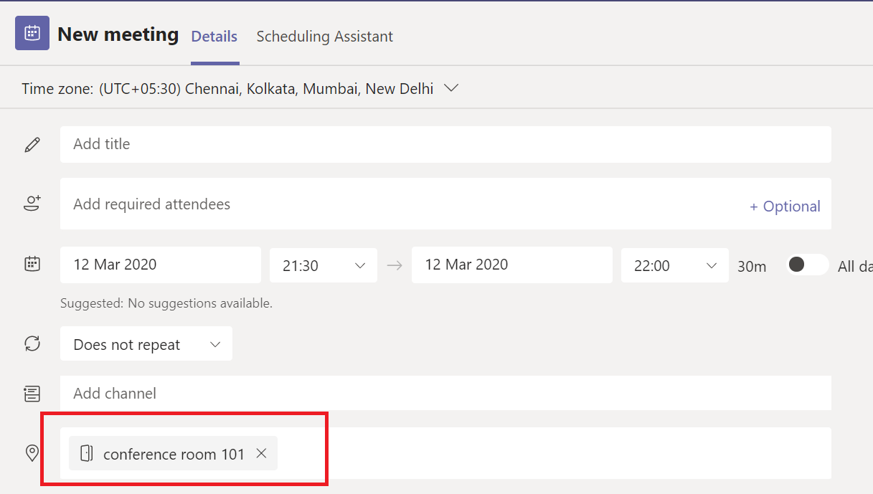

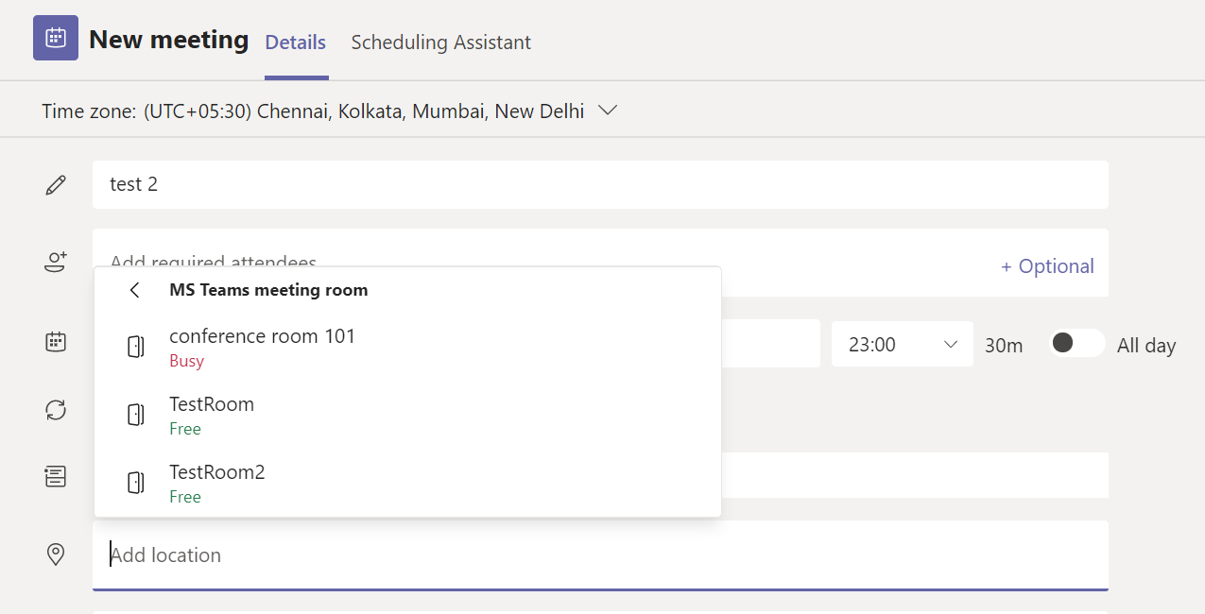

PowerShell Command Reference

